To: Randy Larimer
From: Jay Lamb
Regarding: Lab #6, MicroBlaze Intro
Date: April 20, 2009

Summary:
The goal of the fifth laboratory assignment was to create a UART that would interface the Virtex4 ML403 test board with a PC using a HyperTerminal connection via RS232. The finished product will be able to communicate to the HyperTerminal window with the NEWSC GPIO buttons on the ML403 project board. The PC will also be able to communicate back to the ML403. Characters entered into the HyperTerminal window will write to both HyperTerminal and the LCD that is build into the ML403.

Objectives:
The objective of this experiment is to demonstrate how PicoBlaze can be used in conjunction with a Virtex4 FPGA to drive a UART integrated into the ML403 evaluation board. Like the GPIO buttons and LEDs used in the previous experiment, the LCD will have several connections that will need to be mapped to various input/output pins on the FPGA. In order to construct the system, a basic knowledge of the input/output requirements for the LCD and UART will need to be outlined. With the input/output requirements known, a top-level diagram of the complete system can be created. With the system drawn up, the only remaining objective will be the modification of the VHDL, in order to implement the UART transmitter and receiver. In addition, a pair of new subroutines will need to be added to the PicoBlaze assembly file, to handle the communication between the two devices.

Methods:
First the PicoBlaze architecture needs to be loaded into the FPGA. The Architecture is contained in a file called kcpsm3.vhd. This file contains the entire entity of a single PicoBlaze microprocessor instance. Additional files needed include a program ROM, which contains the actual assembly instructions of the program the user is implementing. Once the assembly file is written, a ROM form file is output, which contains the result of transforming the assembly code (written by the user) into VHDL that the compiler will understand. Finally, a “top” file is needed, which will connect all of the devices in the system.

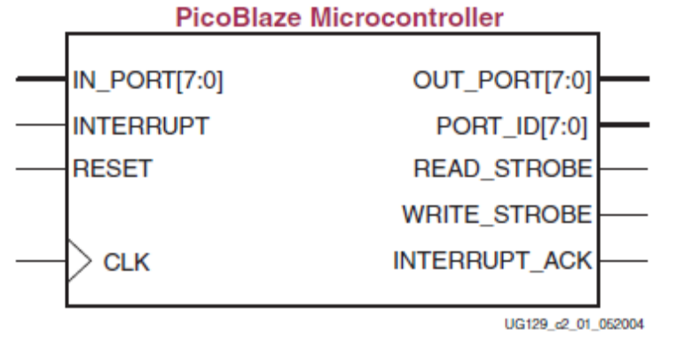
Figure 1. PicoBlaze processor architecture

Next, a layout of the LCD's input/output connections needs to be outlined. The LCD built into the evaluation board has the input/output layout described in figure 2.
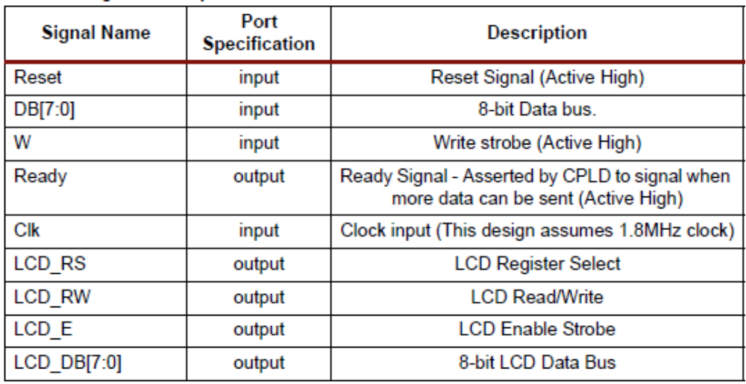

Figure 2. Input/output for the eval. Board LCD

Connections required for this experiment will include all of the available inputs, and all of the outputs, except for the LCD_DB bus.
As soon as the simulation begins, the LCD needs to be initialized before it will operate. The LCD on the evaluation board is constructed only for use in 4-bit mode, so the appropriate initialization codes need to be sent to the LCD before it can be used. Once the LCD has been initialized, it is now possible to write a character to it. This is done by sending the LCD a pair of 4-bit words. Each possible combination of words corresponds to a different character. This is done by setting the EN and RS lines, clearing the RW line, and writing the first nibble to the DB[4:7] bus. Immediately following this step, the second nibble is written to DB[4:7], and is clocked in. Once the two words have been clocked in, the character will appear on the LCD. The system will enter a wait state. While in this state the system will simply run through a loop, waiting for one of the GPIO buttons to be pressed. The process that writes characters to the LCD is sensitive to changes in the values of the GPIO buttons, so if a button is pressed, the data is changed, and the process is triggered, writing the character to the LCD.

Finally, the UART needs to be implemented. Like the LCD, the UART has several input/output connections that will need to be connected to pins on the ML403 in one way or another. The UART’s connections are to the RS232 port on the ML403 test board. This port will then be connected to a PC, and a null modem cable will be used to transmit data between the two devices.
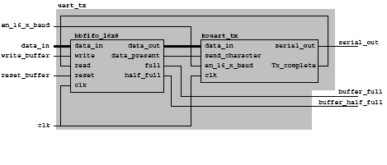
Figure 3. Input/output map for the UART Transmitter (GPIO buttons to HyperTerminal)

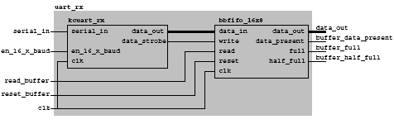
Figure 4. Input/output map for the UART receiver (HyperTerminal to ML403 LCD)

Test:
The easiest and most obvious way to test the transmit function is to see what happens when each of the GPIO buttons is pressed. Pressing any of the five buttons should cause the “write” process to be triggered, causing the corresponding character to appear on the LCD, as well as in the HyperTerminal window. If the correct value appears for each of the five keys, then the code for this process is assumed to be functioning correctly.

Also, the connectivity from the PC to the ML403 needs to be tested. This can be done by simply typing characters into the HyperTerminal window. If they appear on the ML403’s LCD, then the “receive” function is working correctly.

Code (attached):
  - LCD_Driver (assembly code)
  - Top.vhd

